How to use GPG/OpenPGP cryptograpy

Why?
All of us have “open” communication channels, such as e-mail, Slack, other chats. We can not use open channels to share “secrets”: licenses, passwords, access keys and so on. We may use some commercial products to share secrets with colleagues. But, actually, we do not need any commercial products for safe communications. All we need is an easy-to-use free reliable cryptography software. And here it is: Gnu Privacy Guard, or GPG.
Is it safe? Yes, completelly. With 2048 RSA keys is is commercial grade security. With 256 bit Elliptic Cuvers Cryptography (ECC) keys is is military grade security. So, let’s use it!

Installing GPG and GPG Frintend

Ubuntu and familiy
First, install gnupg services:
sudo apt update
sudo apt install gnupg

Verify the installation:
gpg --version

Then install GUI frontend:
flatpak install flathub com.bktus.gpgfrontend

Alternatively, download the AppImage or Linux package from the GpgFrontend Downloads page.
Another modern GPG frontend is Kleopatra. It is A certificate manager for OpenPGP and X.509 (S/MIME) and common crypto dialogs.
sudo apt install kleopatra
It has more capabilities and included in all popular Linux distributions.

Windows
The official package of GPG is Gpg4win. You can download installation from the Gpg4win site.
The Gpg4win contains:
- GnuPG, the backend; this is the actual encryption tool.
- Kleopatra, a certificate manager for OpenPGP and X.509 (S/MIME) and common crypto dialogs.
- GpgOL, an add-in for Microsoft Outlook providing email cryptography. Supports both IMAP/SMTP and MS Exchange servers
- GpgEX, a plugin for Microsoft Explorer (file encryption).

How to use cryptography
TODO: explain what it is and why we need it

All workflow and screenshots below are based GpgFrontend GUI. For Kleopatra it is very similar.

Creating you key pair
Start GpgFrontend. You will see following:
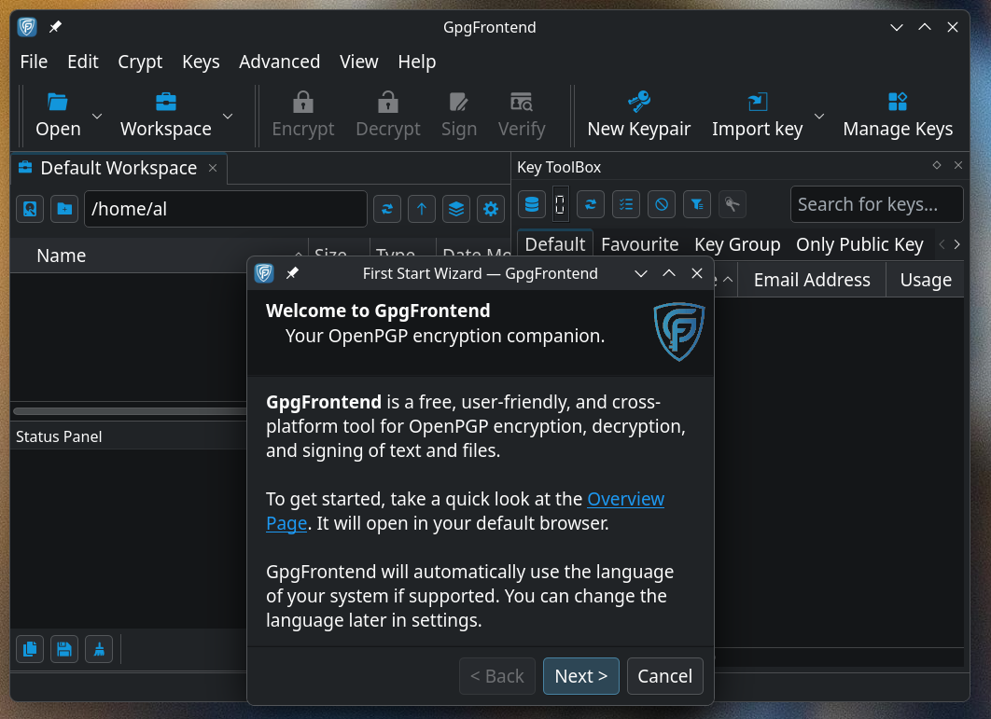
Click “Next” several times, then “Finish”.
To create your key pair, fo to menu and choose “Keys→New Key pair”
Fill fields as screnshot shows.

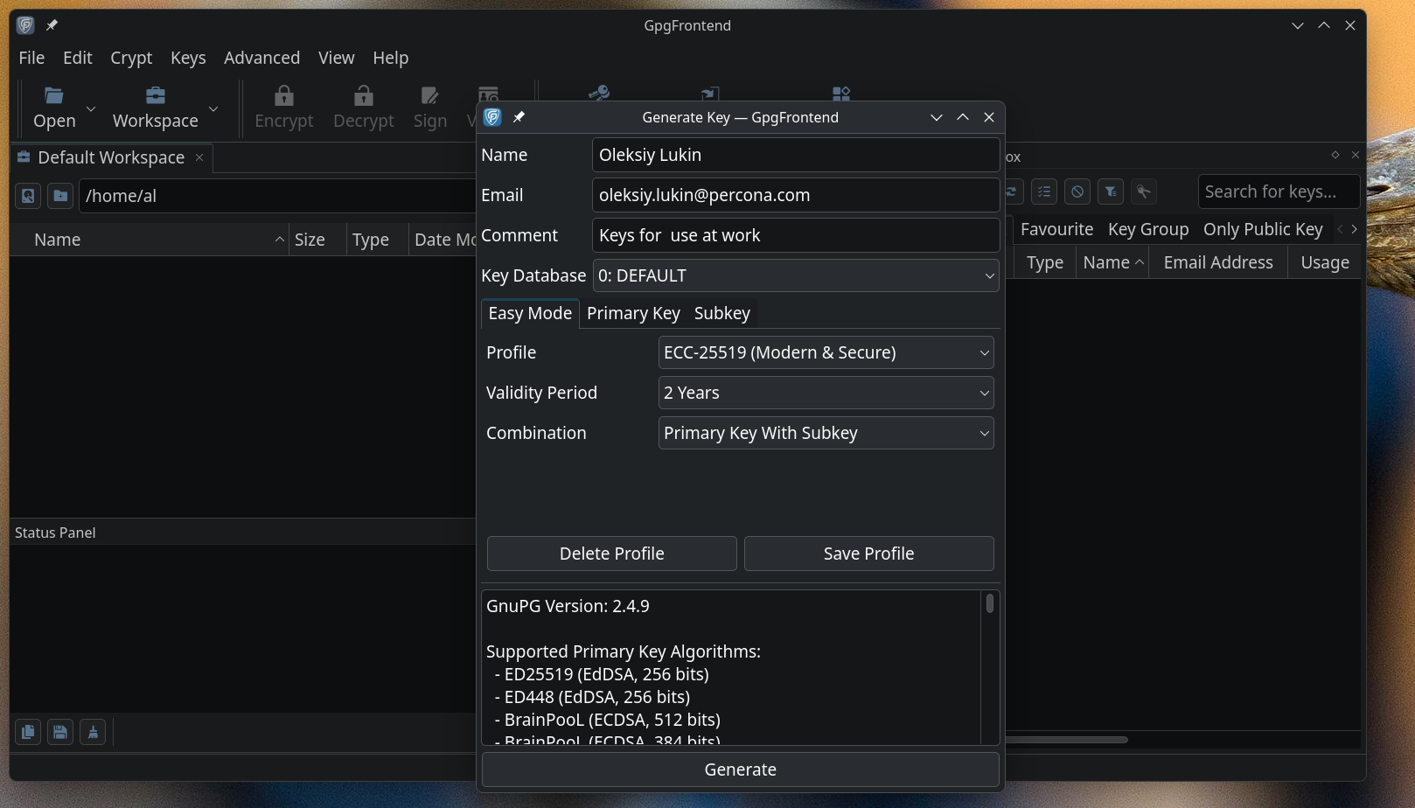
Note, that Profile uses EC-25519 cryptography keys instead of default RSA 2048. It is Eccliptic Curve Cryptography with de-facto Internet standard Ed25519 curve. Elliptic cryptography is more secure with much shorter keys.
Normal key validity period is 2 years. After 2 years you should generate new key pair. The “Combination” field should be set as shown.
Click “Generate”. GpgFrontend will ask you for private key passphrase. It is a password to “open” your private key for use. Remember this password, you will need it for decryption and digital signing operations.
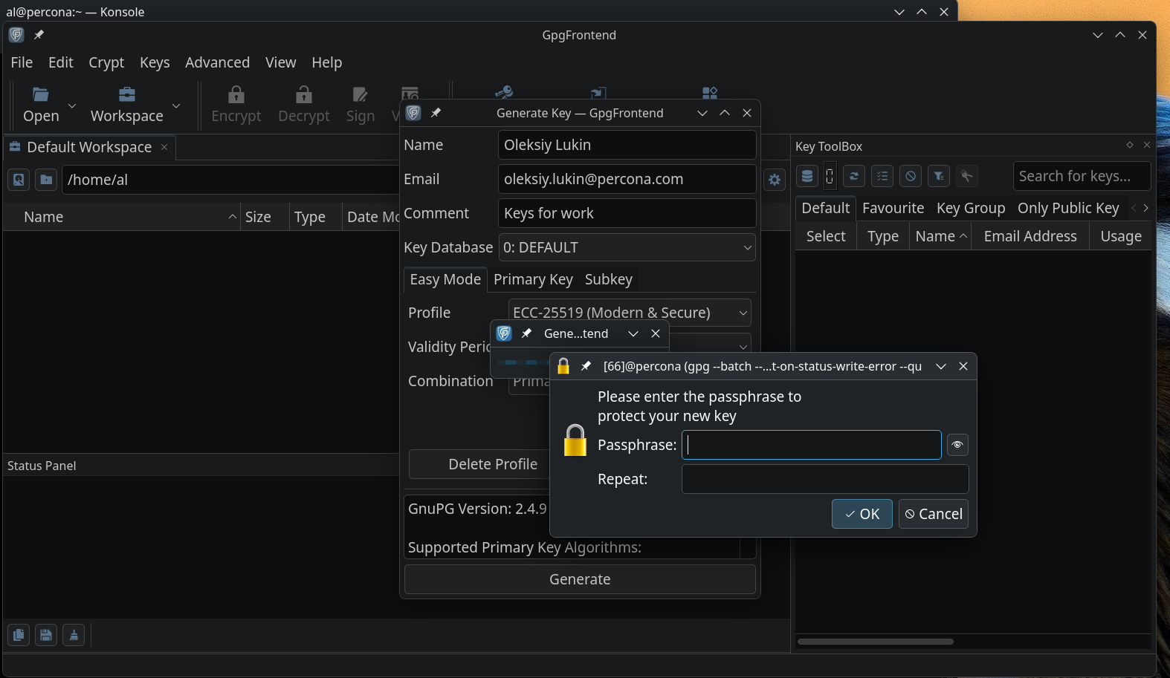
Then you will have your keys ready.

Pubish key on key server
Now we have to let the world know that we can acept encrypted messages. It is perfectly safe to publish your public key, just because by definition: it is public key.
Right click on your key, then Append Public Key To Editor, then File→Save as.
This action will save your publlic key to file.

Go to https://keys.openpgp.org/ and click on “You can also upload or manage your key.” link.
Upload saved file. Server requires key activation by e-mail. It will send you e-mail with activation link. Open your e-mail and find verification e-mail from the key server. Click verification link. Now your publlic key is available for search by e-mail to everyone who wants to send you encripted email.

The keys.openpgp.org server it used because of that e-mail verification. Antother server keyserver.ubuntu.com does not perform e-mail verification, that’s why we have to set keys.openpgp.org server as default. Go to Edit→Settings→Key server, righ-click on keys.openpgp.org and choose “Set as Default”.

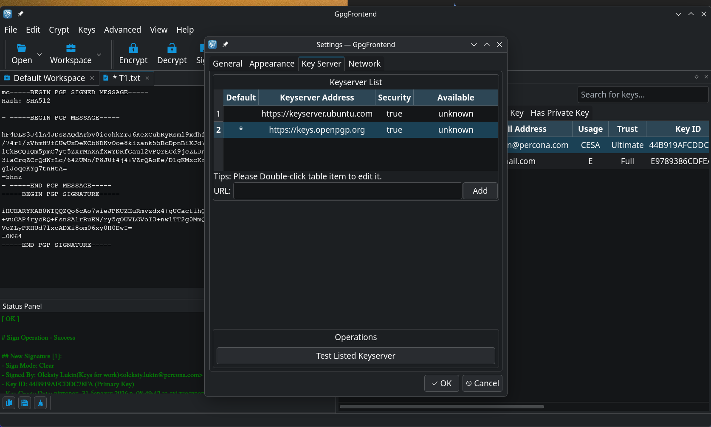
Now your public key is available for the world and searchable by e-mail. Most e-mail clients can request public key from this server by e-mail addres in the To: field.

Now it is good idea to import several keys of you colleafues and friends. You can search and import public keys from key server or just import key from the file your fellow sent you directly.
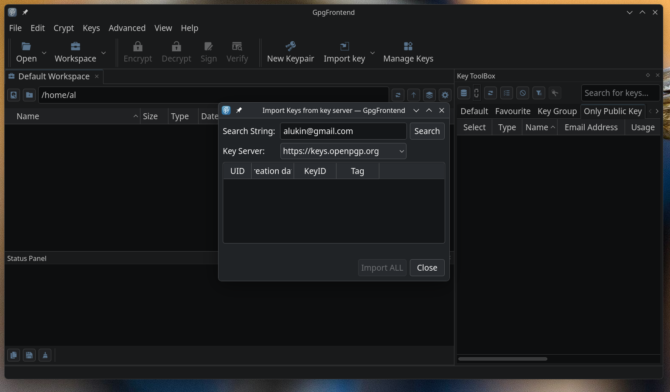
Here is import from key server window. Enter e-mail and click Search. Look at the keys you’ll find carefully and import only keys you recognize. To be 100% sure, you can ask your fellow to send you a key “fingerprint” and verify it in this window.
Public keys are not secret ones, but still very important. You must have up-to date active key of your respondent to encrypt the message for him/her. If you use wrong key, the respondent then can not decrypt the message with a private key.

Encrypt-decrypt and Sing-Veryfy with GpgFrontend.
Let me explain things, as cryptographers do. We have 2 actors, Alice snf Bob. Usualy, Alisa is the actor who sends message, and Bod recieves it. So the story goes:
- Alice writes a secret message in a plain text.
- Alice takes her private key and signs message to ensure message integrity and authorship.
- Alice takes Bob’s public key and uses it to encrypt message.
- Alice sends encrypted message via open channel.
- Bob receives encryped message from Alice
- Bob uses his private key to decrypt message and gets plain text.
- Bob uses Alice’s public key to verify message integrity and authorship.
That’s it. Now you know what to do in GpgFrontend. Try this with your fellow.
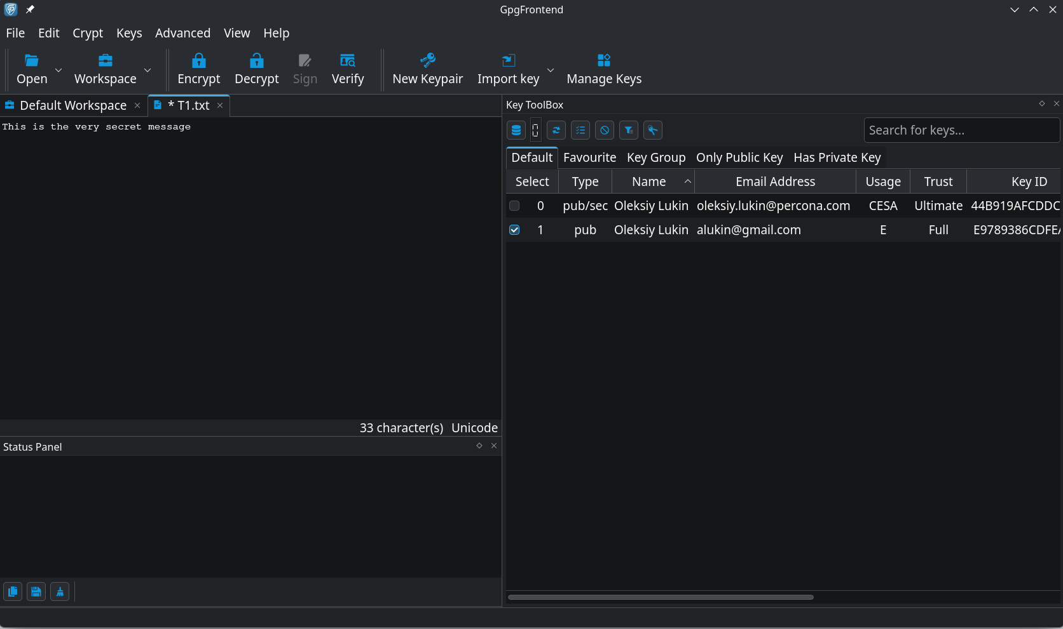
This example show plain text message before encryption
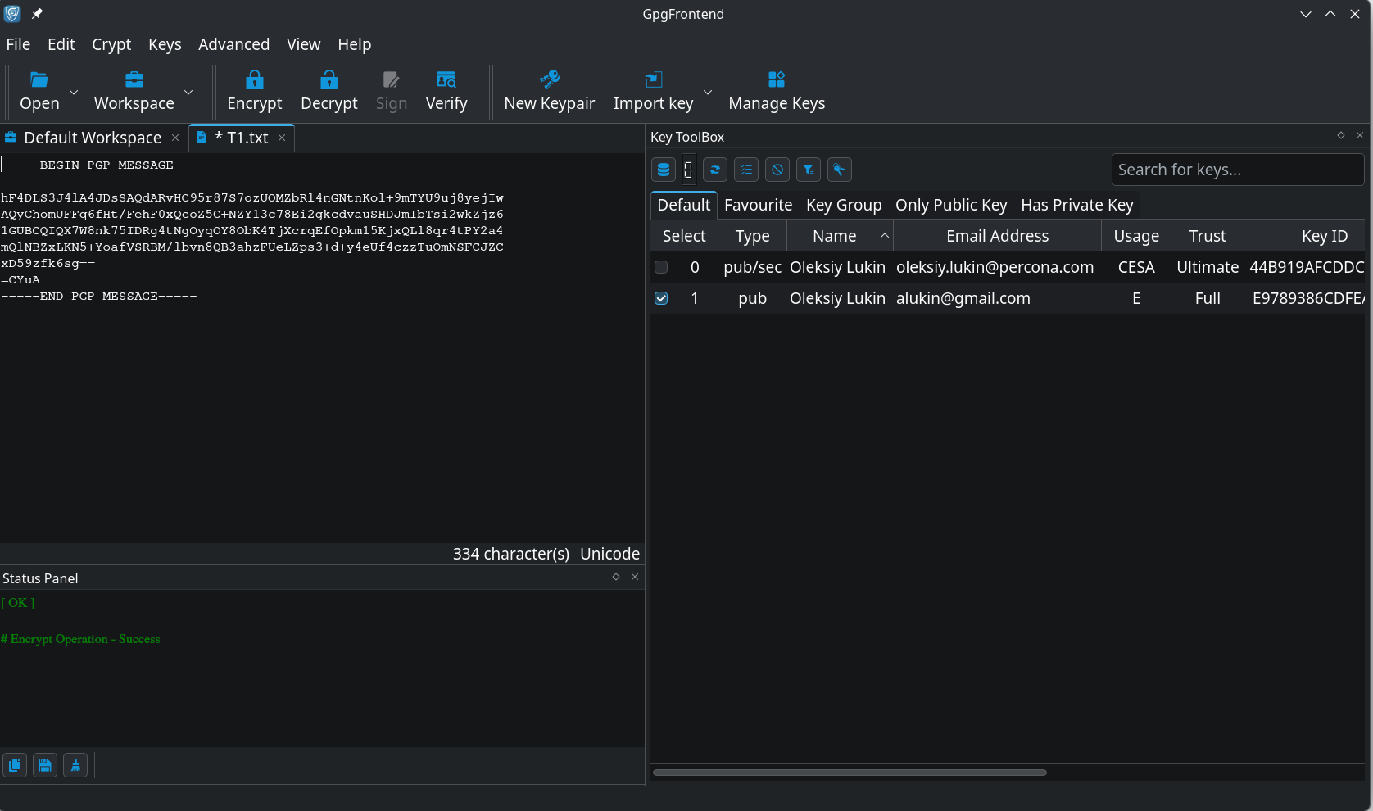
And this is after encryption. As you can see, there are “brackets”: “----BEGIN PGP MESSAGE-----” and “-----END PGP MESSAGE-----”, encrypted text is “encosed” between these “brackets”.
You can “cat’n’paste” this message into e-mail or any messenger and send it to the repondent.
Then, the respondent will “cat’n’paste” this message to GpgFrontend editor window and decrypt it using private key.

So, we have sent this message to our respondent, alukin@gmail.com, and he replied usin open or not entirely secure channel, let’s say in Viber or Slack. We cut’n’past the encrypted message from this channel tou out GpgFrontend:
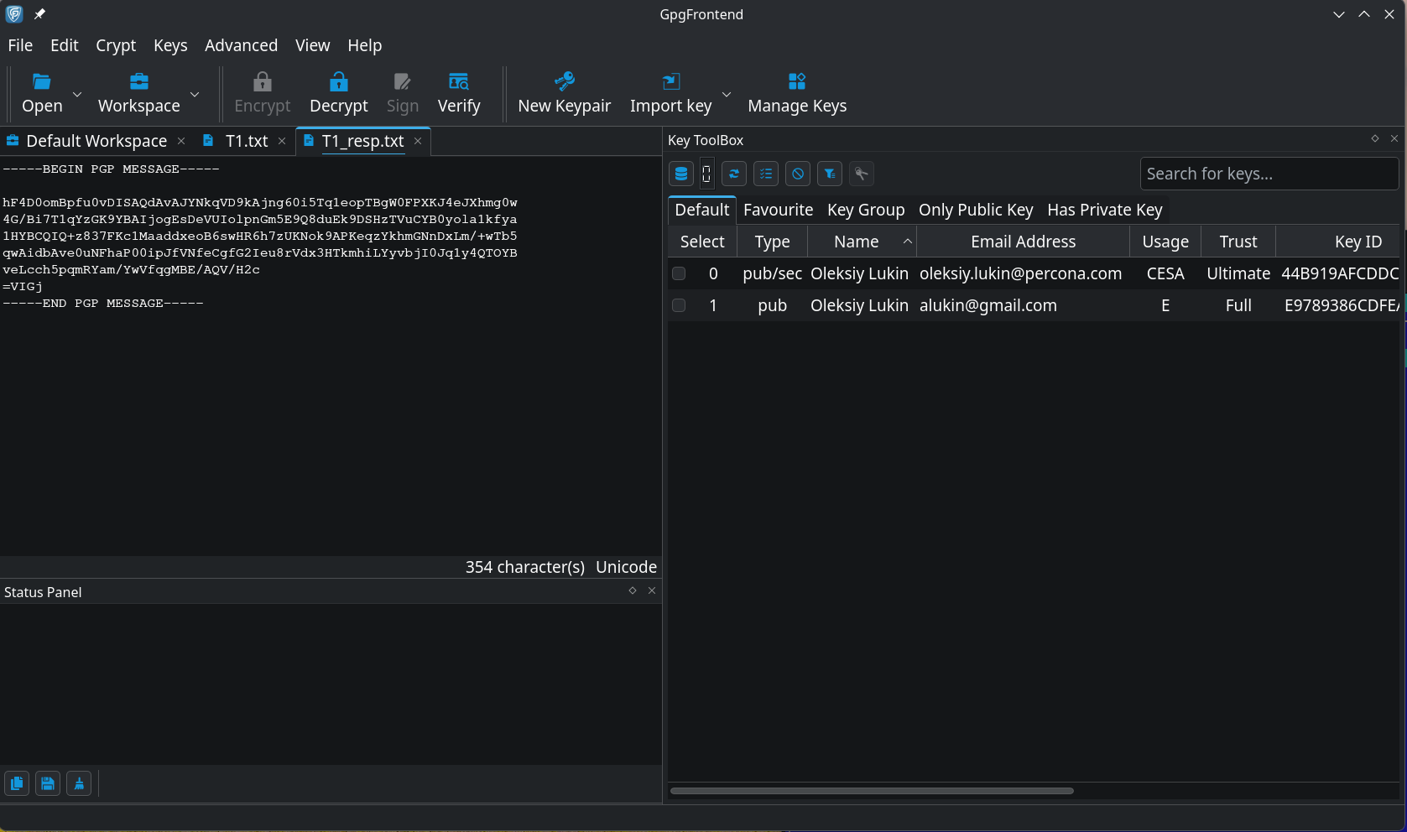
Next step is to choose our private key, enter password and decrypt the message.
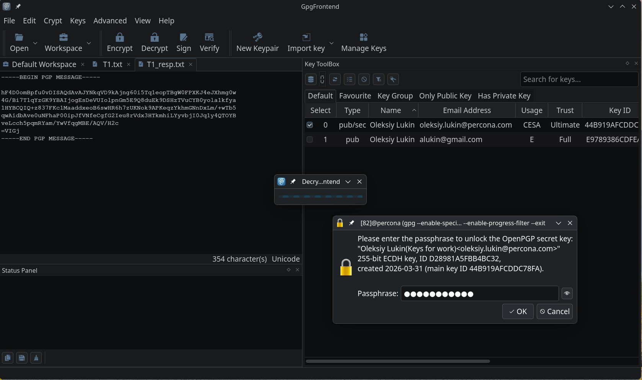
And here is the reply to our message.
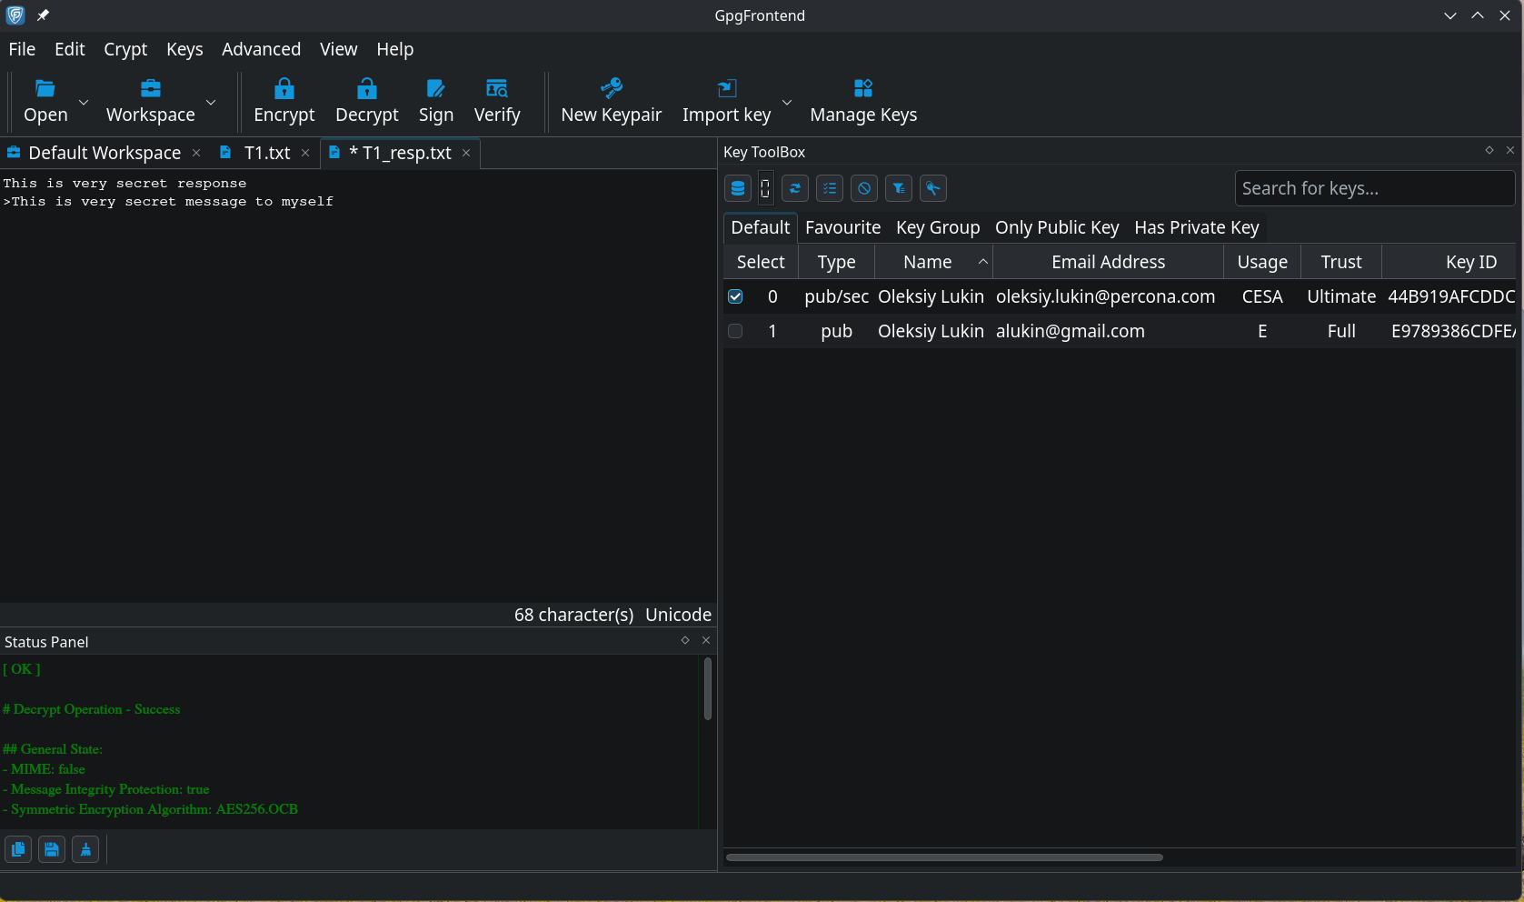
That’s all.

Other key managers

Another GPG GUI, kalled Kleopatra, hast slightly different interface, but it is easy to use now, when you know what to do.
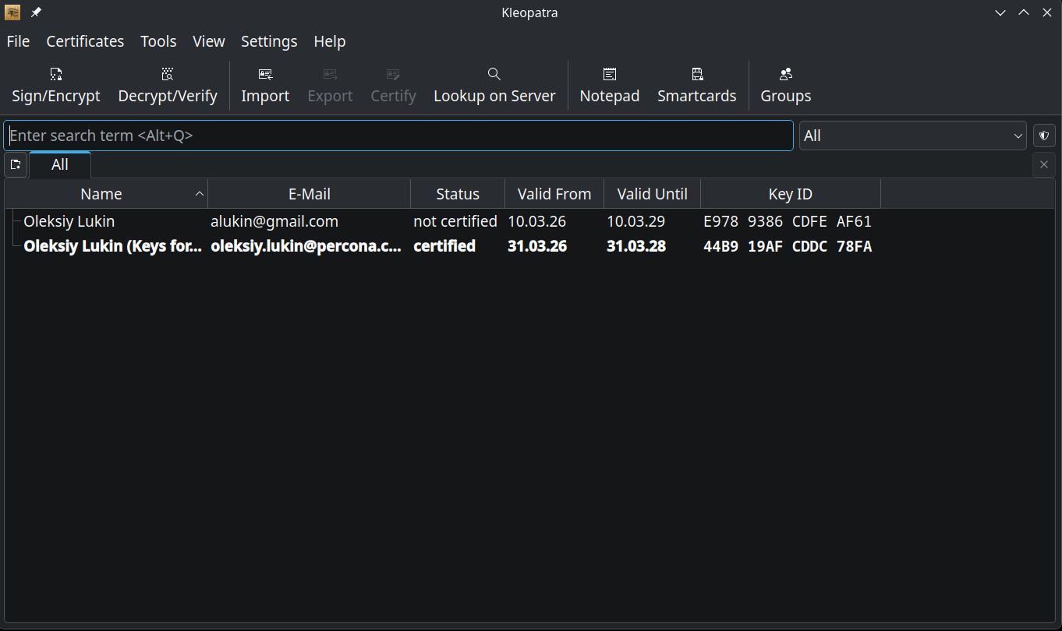
Keopatra is a part of KDE Plasma desctop and also comes with Gpg4win installation. Both, Kleopatra and GpgFrontend use the same backend gnupg.

Experinced Linux users love terminal and command line. The all-in-one command id “gpg”. Please read man pages or just “gpg -h” output. It is easy now to understand everything, because you saw pictures above.

What’s next?
Next step could be secure e-mail c lilent with GPG built in. And it is Thinderbird.

